**Shaders Project 3**

**Seyedehdelyar Tabatabai**

[**tabatase@oregonstate.edu**](mailto:tabatase@oregonstate.edu)

* **What you did and explaining why it worked this way:**
  + In this project, we have a quad having some pleats on it. Here we are using displacement mapping to create the pleats. In order to make the wave shape on the quad, i am using a sin funcion that depending on x, and the value of p, calculates the new value of z. So instead of showing the vertices on the correct z placement, we displace them with this formula: **z = K * (Y0-y) * sin( 2.*π*x/P ).** Also, we are creating a texture on the object which gives the feeling that the object is being displaced but actually it is not. We are using the norms to make this happen.First we need to create two noise values one for x angle and one for y angle. Then we will rotate the norm on our object based on the noise in the given angles.
* **Side-by-side images showing different values for the input parameters**

K = 0:

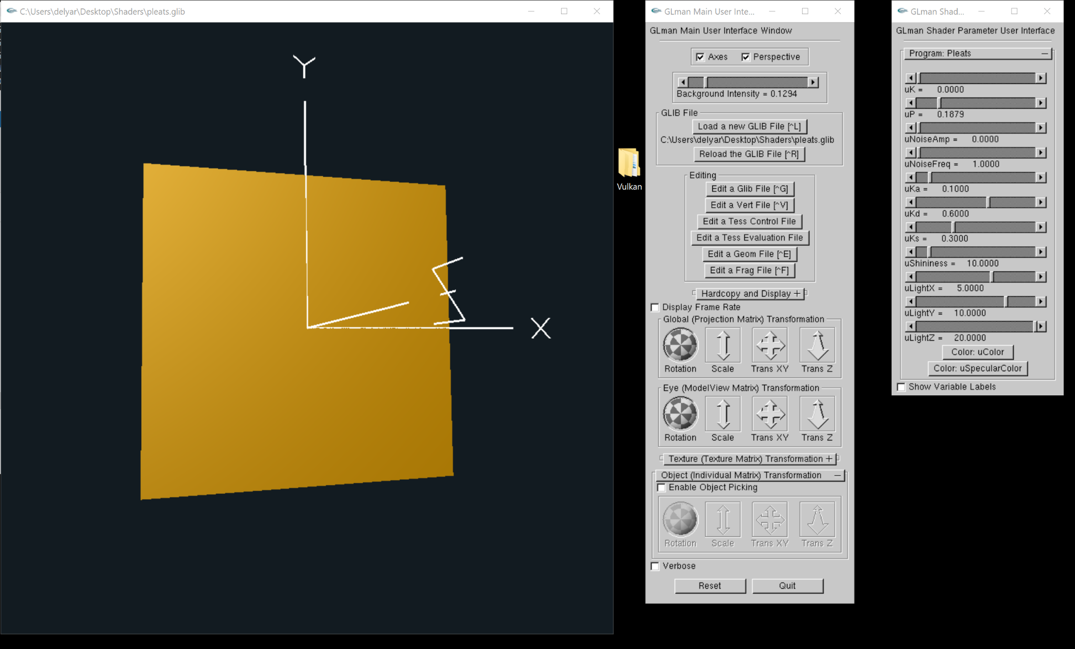

K = 0.1

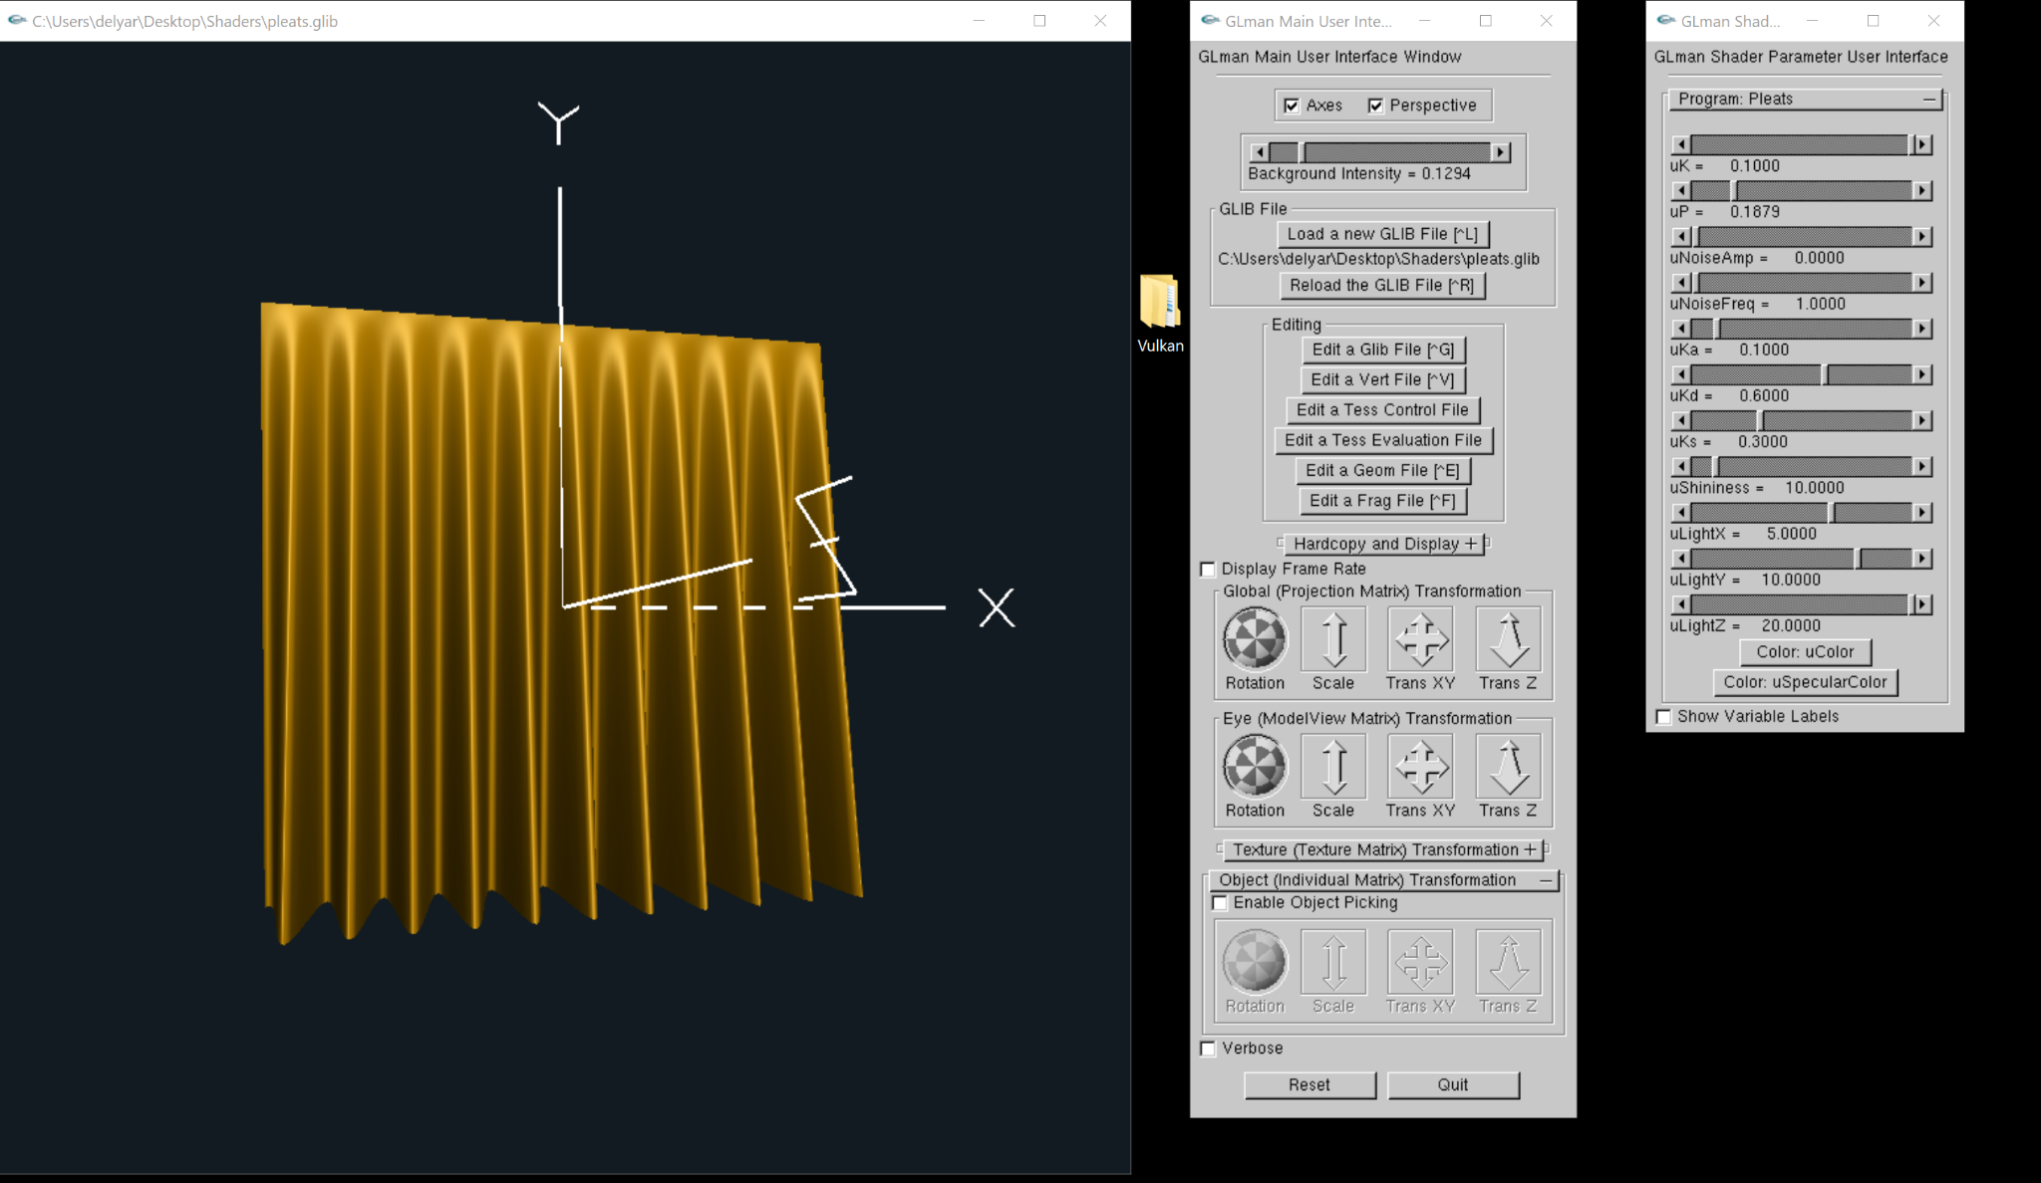

P = 0.01

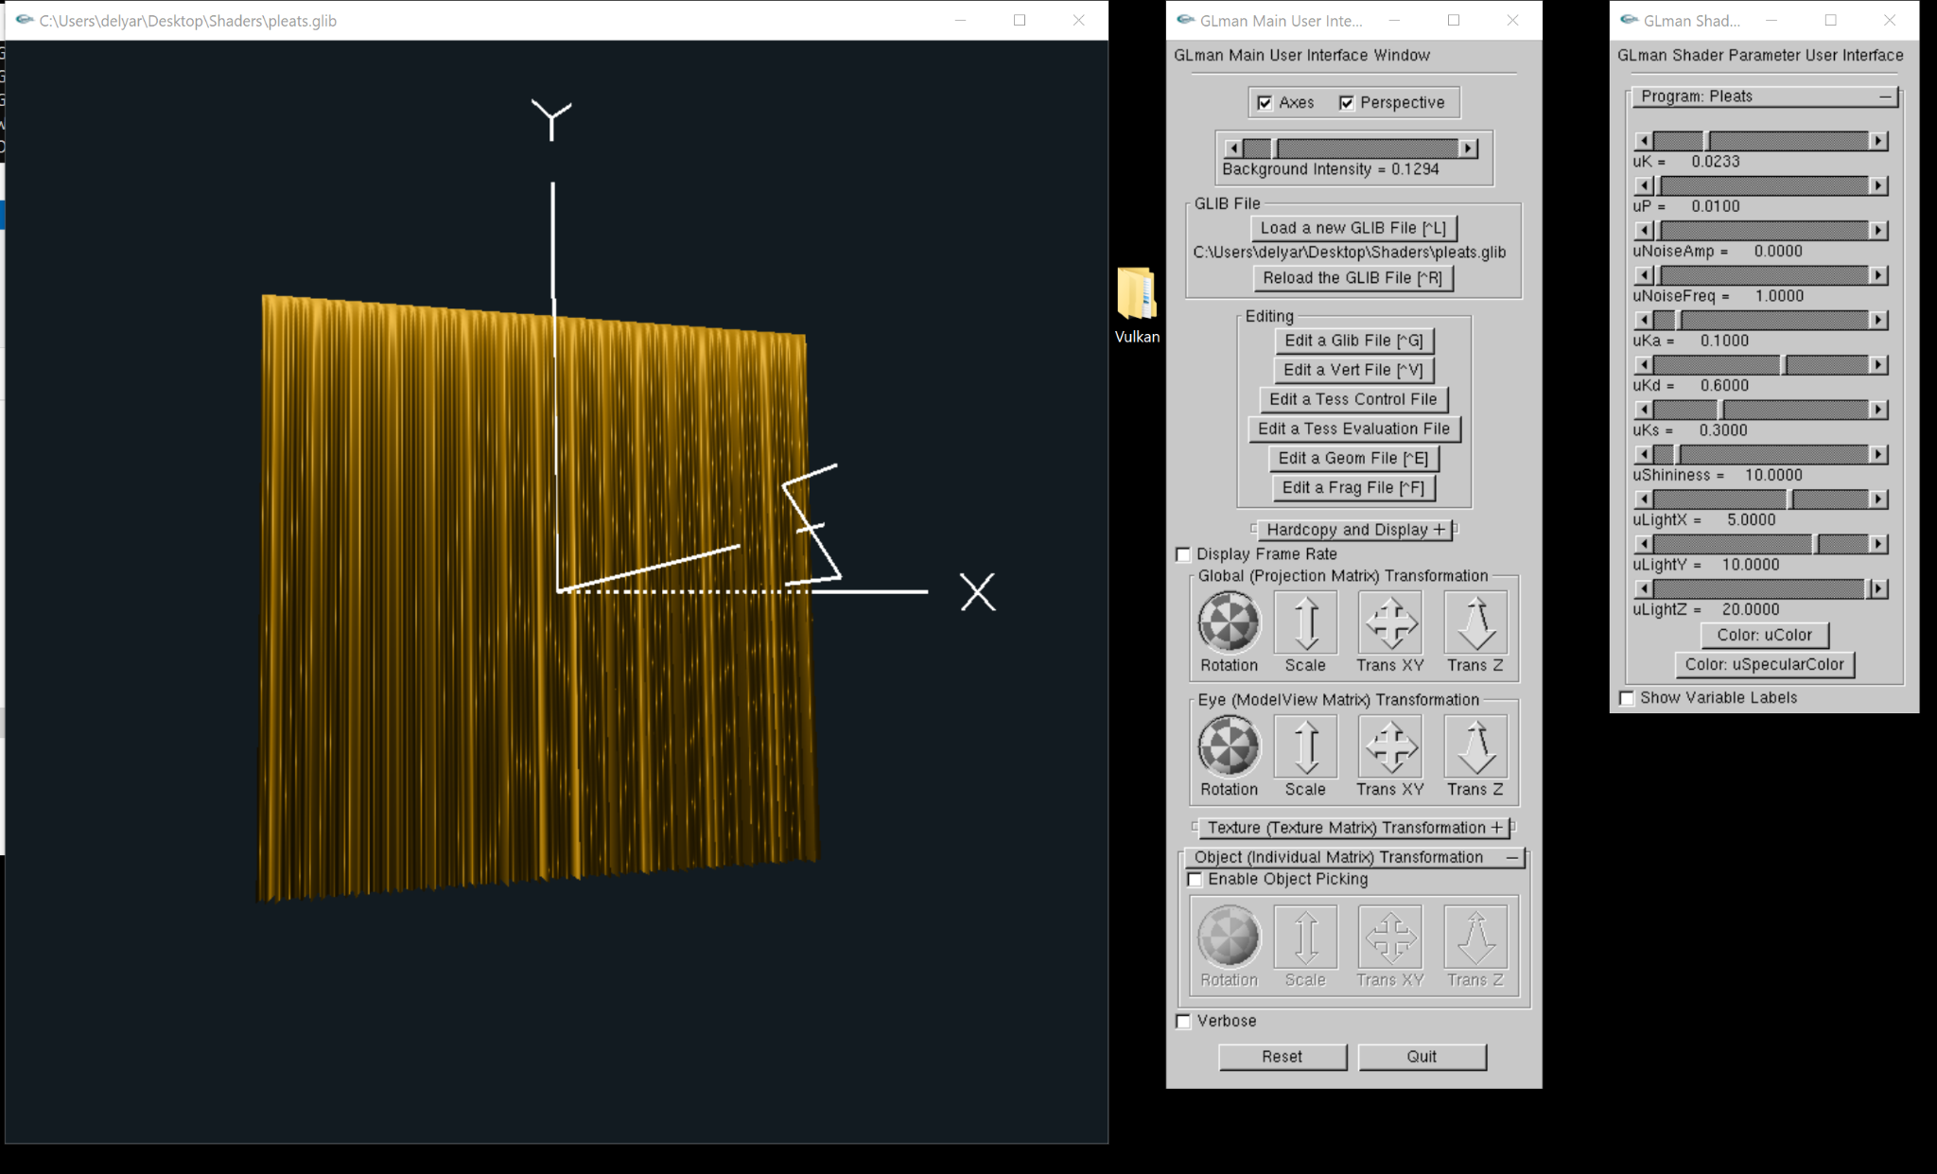

p= 1.0

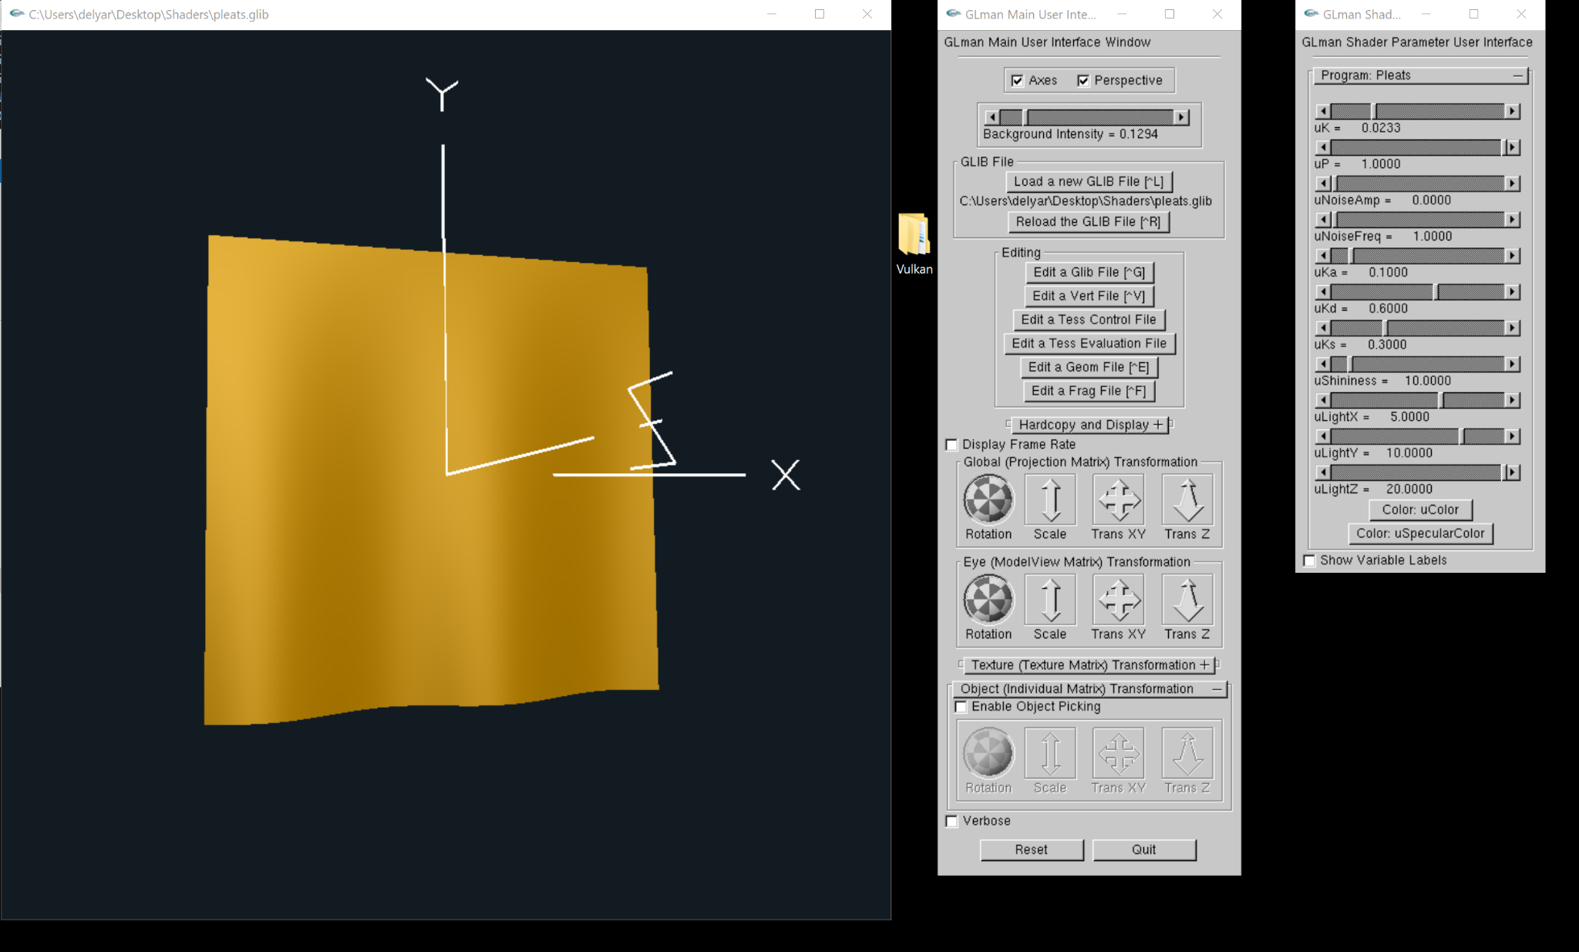

noiseAmp = 0.0

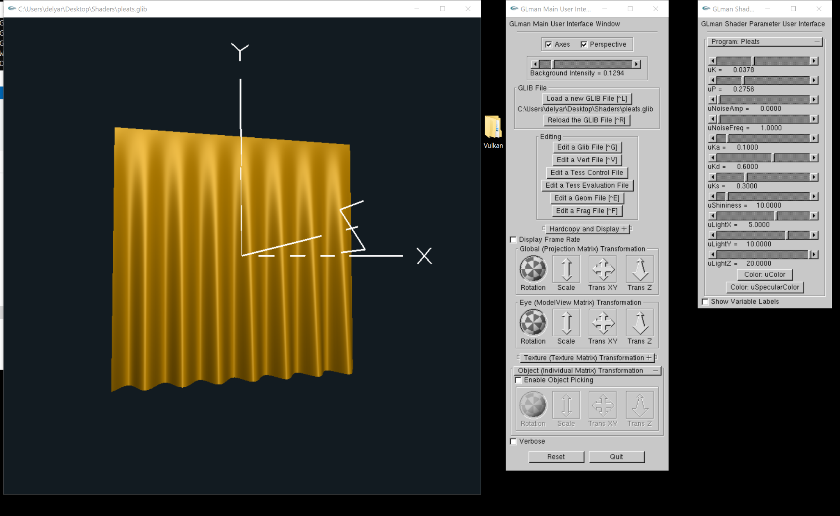

Noiseamp = 2,9

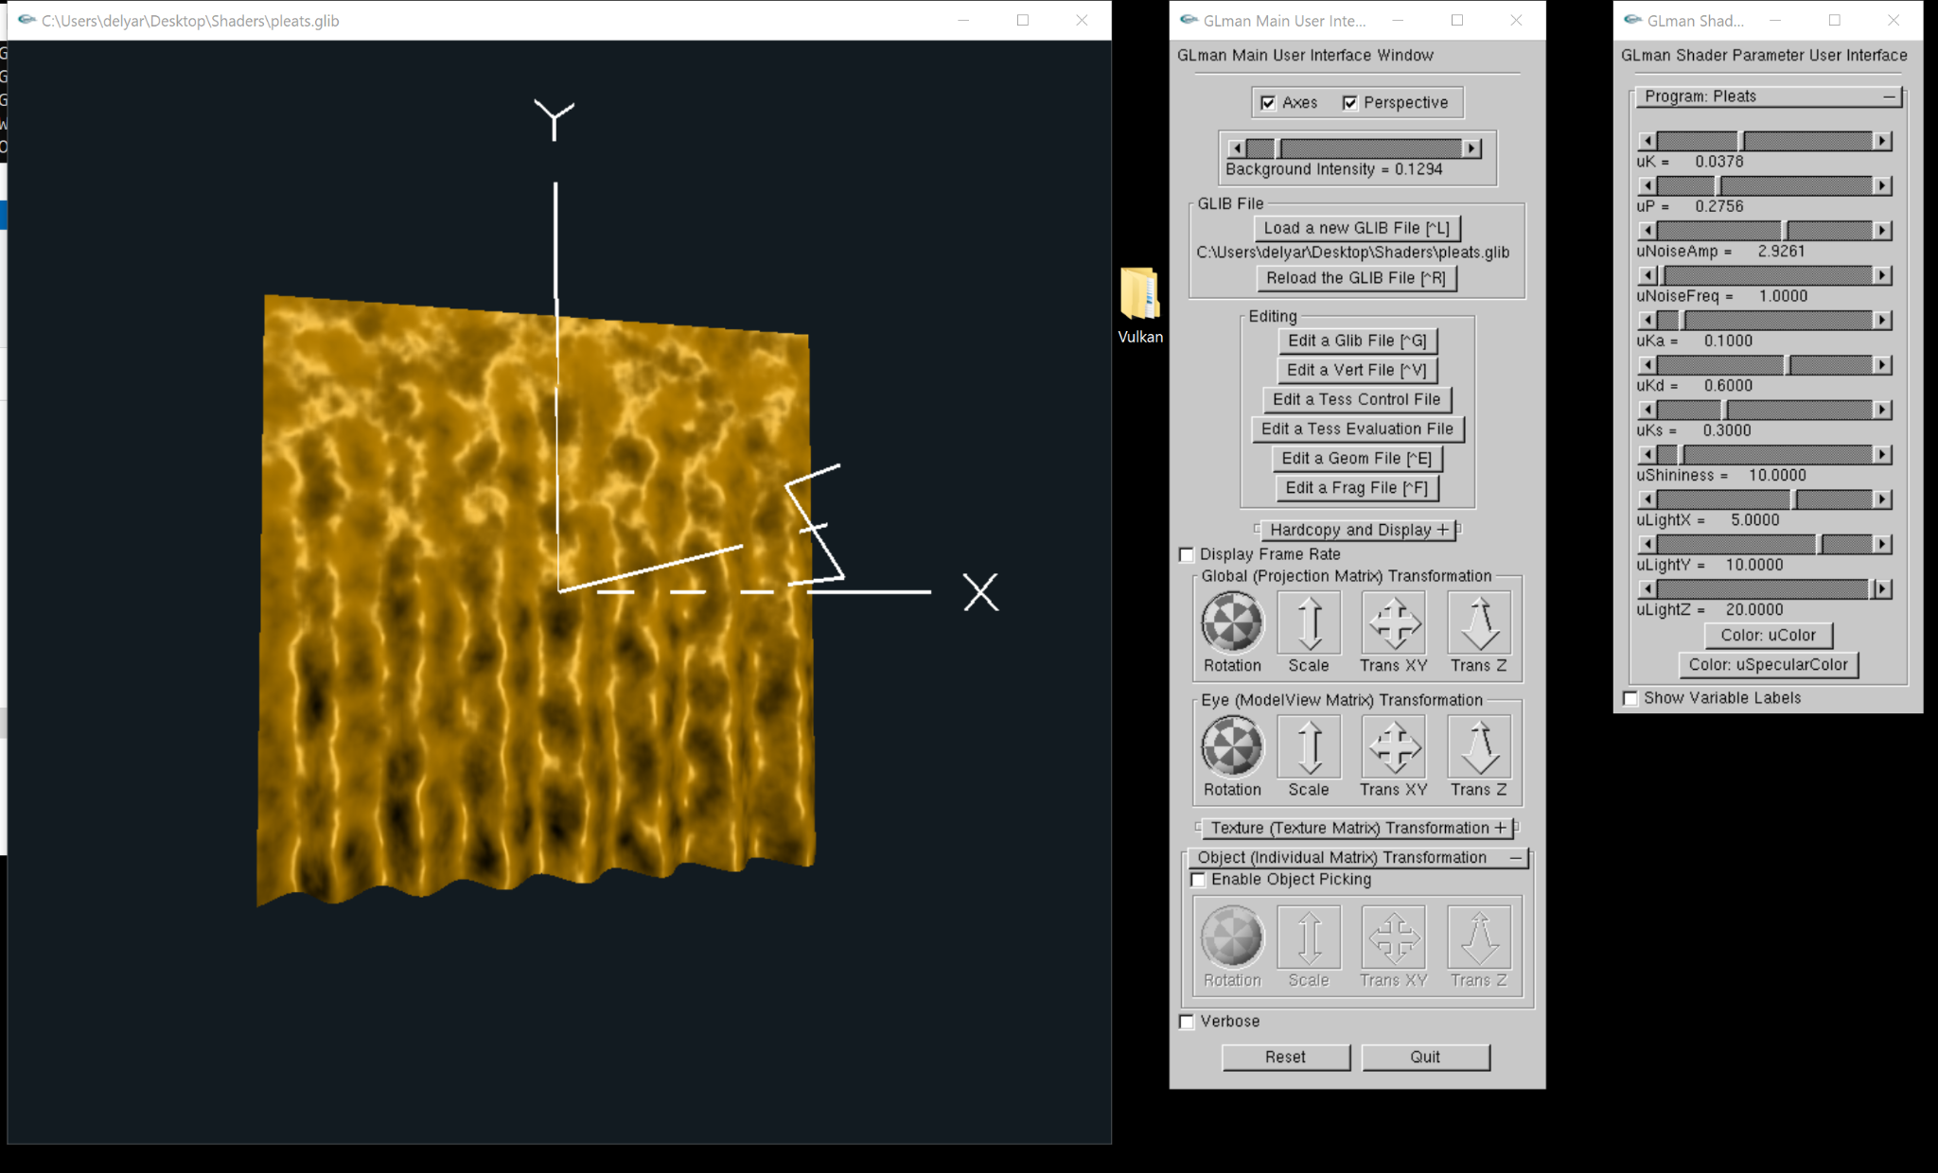

NoiseFreq = 2.7

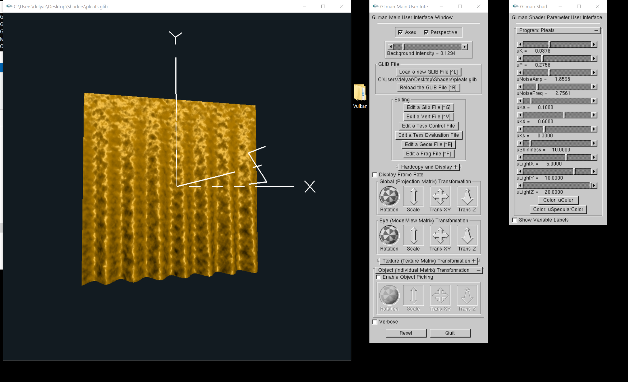

NoiseFreq = 6.04

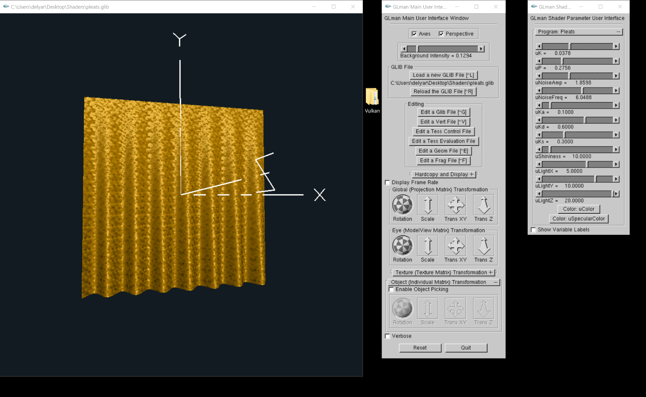

* **Per-fragment lighted image(s) showing that your normal computation is correct.**
  + Please refer to the above screenshots
* **Per-fragment lighted image(s) showing that your bump-mapping is correct.**
  + Please refer to the above screenshots
* **A link to your video**
  + [**https://media.oregonstate.edu/media/t/1_bbjngrt0**](https://media.oregonstate.edu/media/t/1_bbjngrt0)